Number are increasing as expected as of 2015.

Again number are increasing by country. Gives comparative #people taken in by each country.

Uncannily same structure.

A lot of Adolescents affected.

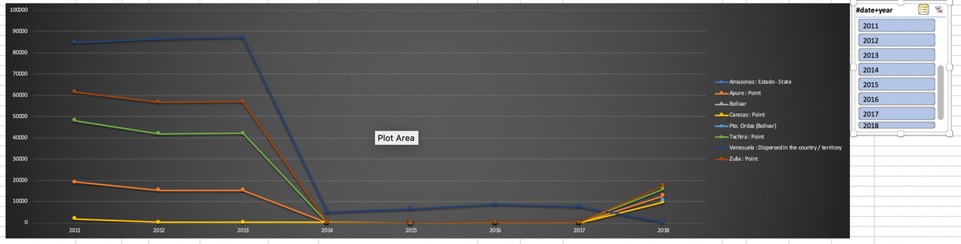

Region data fucked up.